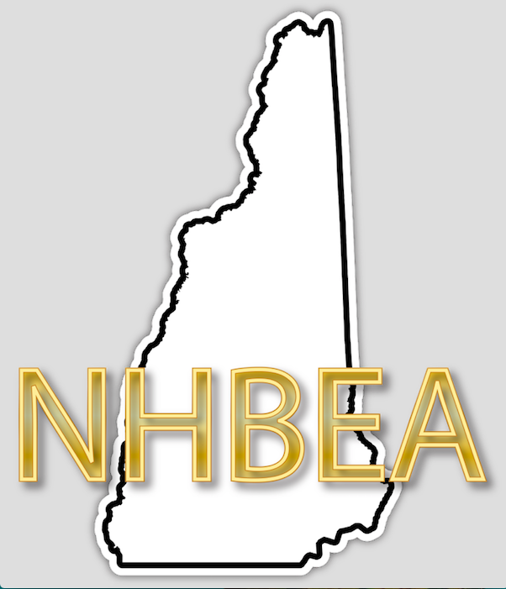
NHBEA BUSINESS EDUCATOR OF THE YEAR
NOMINATION FORM

The NHBEA EDUCATOR OF THE YEAR is given annually to a current member of the Association. The nominee should exemplify the standards and passion for business education and its continued growth. The recipient will go on to represent New Hampshire Business Education Association as our EDUCATOR OF THE YEAR at the New Hampshire “ED”ies Award Ceremony.

YEAR:
NOMINEE:
NOMINATED BY:
CONTACT ME:
DETAILS ABOUT THE AWARD NOMINEE:

Please forward the completed form to be received NO LATER than April 4 to:
Ms. Barbara Wirth, NHBEA Past President, UNH-Manchester, 100 Commercial St., Manchester, NH 03101

